

NOVAC TECHNOLOGY SOLUTIONS

User Manual

Document Version No.: 1.00

Revision History
Version No | Reason For Changes | Author | Approver
0.01 | Draft | Ravi
1.00 | Reviewed & Approved the User Manual | Ravi | NIJANTHAN PL

Table of Contents
1. Introduction 4

2. Claim Intimation Mode Receipt 4

Introduction

The document is prepared to understand the reports generated in ZIVA application. This document is being prepared in reference to,
- Guidelines, circulars, instructions and directions released from time to time by Philippines Insurance council.

Functional Overview

System should have the provision to generate the Claim intimation report for all products.

Claim Intimation Report

System should have the provision to generate the Claim Intimation Mode Report based on the input parameters. System should generate the report in “.xls” format.

Search the Claim intimation interface Report Screen.

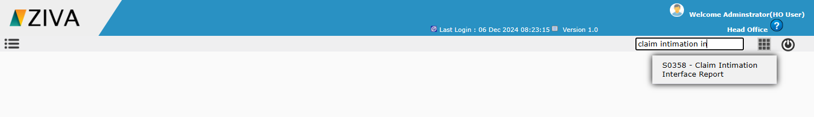

Click on the Claim intimation interface Report Screen. System will display the Report details tab.

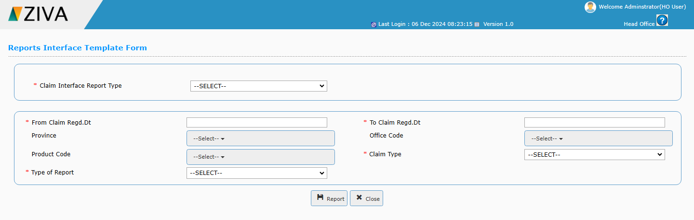

Select the Claim Intimation report in the dropdown.

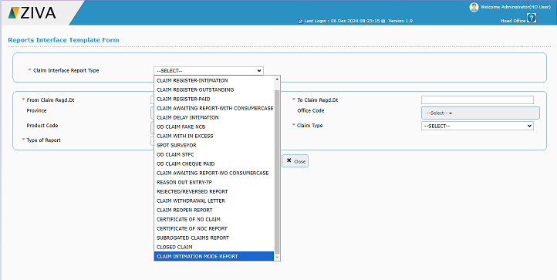

Enter all the details and click on Report button.
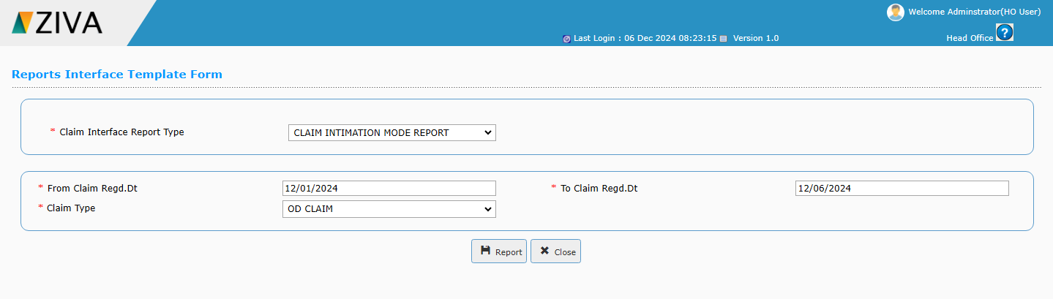

Click on the view button to download the report.

